Project Handbook.

Date Ending: Jan 28th 2022.

This week I evaluated main controllers and made the decision to use the raspberry pi the following document explains why.

# Raspberry Pi 4.

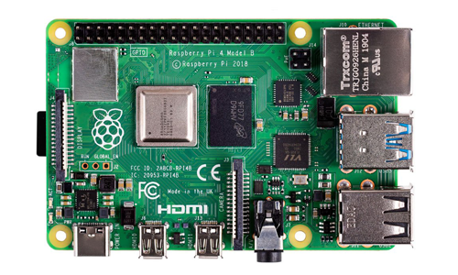

Raspberry Pi 4 Model B was released in June 2019 it contains on-board 802.11ac Wi-Fi, Bluetooth 5, full gigabit Ethernet, two USB 2.0 ports, two USB 3.0 ports, 2-8 GB of RAM, and dual-monitor support via a pair of micro HDMI ports.

It offers ground-breaking increases in processor speed, multimedia

performance, memory, and connectivity compared to the prior-generation

Raspberry Pi 3 Model B+, while retaining backwards compatibility and similar

power consumption. For the end user, Raspberry Pi 4 Model B provides desktop

performance comparable to entry-level x86 PC systems.

Not only is this SBC top of its range, there is also a wealth of information and tutorials available to learn from.

|  |  |
| --- | --- |
|  |  |

Inside the Pi the user can choose to learn different programming languages including Python, C/C++, Scratch and they can also learn Scripting.

# ODROID XU4

ODROID-XU4 is a new generation of SBC device with more powerful, energy-efficient hardware and a smaller form factor created by a company called Hardkernel.

It offers open source support, the board can run various flavors of Linux, including the latest Ubuntu 16.04 and Android 4.4 KitKat and 7.1 Nougat.

At first, it was designed to act as a development platform for developers.

Now, it’s popular with the hobbyist market.

With Hardkernel’s SBCs, many multi-purpose projects have been created including a home theater PC for Kodi.

The Odroid XU4 was released in 2015 but remains a contender to the raspberry pi.

Even though the SBC comes with GPIO pins, the XU4 functions at 1.8 V, a marked difference from the Pi’s 3.3 V.

As a result, the XU4 is incompatible with many accessories on the market that operate at 3.3 V or 5 V.

That said, this problem can be solved with the addition of a Shifter Shield, which enables the Odroid to be used with higher voltage accessories.

This accessory gives some leverage, but hardware-based pulse-width modulation (PWM), software PWM, and serial peripheral interface (SPI) are not supported.

I would find it hard to get sensors if I was to choose this board

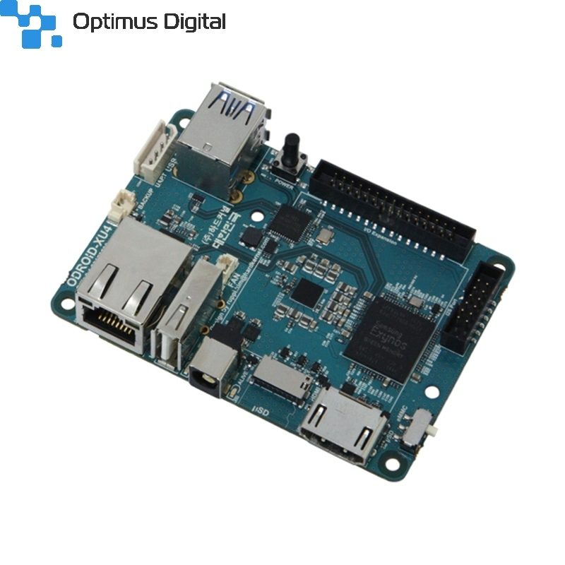

https://all3dp.com/2/odroid-vs-raspberry-pi-difference/#:~:text=On%20paper%2C%20the%20Odroid%20XU4,3.0%2C%20and%20Gigabit%20Ethernet%20interface.

# ASUS Tinker Board.

Tinker Board is a Single Board Computer (SBC) in an ultra-small form factor that offers class-leading performance while leveraging outstanding mechanical compatibility. #

The Tinker Board offers makers, IoT enthusiasts, hobbyists, PC DIY enthusiasts and others a reliable and extremely capable platform for building and tinkering their ideas into reality.

Even though they are similar in form factor, there are some notable differences between the Tinker Board and the Raspberry Pi 4.

One of the biggest is that the Tinker Board has a full-sized HDMI port instead of the two Micro-HDMI ports found on the Pi.

The Tinker Board also is powered by Micro-USB, instead of the non-standard USB Type-C on the Pi 4. Lastly, the Tinker Board has 4 x USB 2.0 ports instead of the array of 2 x USB 3.0 and 2 x USB 2.0 that’s on the Pi 4

# Banana Pi M5.

Banana Pi open source hardware community is an open source hardware project led by Guangdong Bipai Technology, and supported by Taiwan Hon Hai Technology (Foxconn).

Banana Pi open source hardware series development board, complete the core system and architecture design. The development documents, software, and hardware (including schematic diagrams) are all open, the purpose is to allow all developers around the world to participate.

Banana Pi BPI-M4 use Realtek RTD1395 chp design ,it is a 64-bit quad-core A53 mini single board computer. It features 1 GB/2GB of RAM and 8 GB eMMC. It also has onboard WiFi for b/g/n/ac and BT 4.2. On the ports side, the BPI-M4 has 4 USB 2.0 ports, 1 USB TYPE C port, 1 HDMI port, 1 audio jack. support M.2 Key E PCIE 2.0 interface.

Even though this type of pi is very similar or even better than a raspberry pi, it has a very small community compared to it, this is the main reason why I’m sticking with the Raspberry pi as there is more information available about it.

# Arduino.

Arduino is an open-source hardware and software company, project, and user community that designs and manufactures single-board microcontrollers and microcontroller kits for building digital devices.

In order to interface this to WIFI or ethernet we have to buy an add on board, which is also a microcontroller, there is limited memory, and limited Pin IO compared to other boards the only real long term memory is limited to the EEPROM, which is limited to 1K.

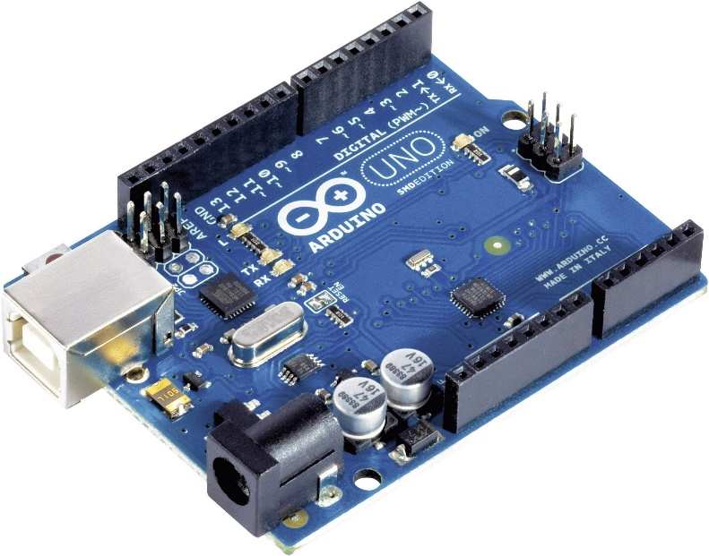

# Weekly Results and Summary.

|  |  |  |  |  |  |
| --- | --- | --- | --- | --- | --- |
| **Controller** | **Cost** | **RAM** | **GPIO** | **Bluetooth** | **WIFI** |
| Raspberry Pi 4B | $35.00 | 8GB | 40 pin | V5.0 | Wi-Fi 802.11b/g/n |
| ODROID XU4 | $95.00 | 2GB | N/A | N/A | Wi-Fi 802.11b/g/n |
| ASUS Tinker Board | $105.00 | 2GB | 28 pin | BLE | Wi-Fi 802.11b/g/n |
| Banana Pi M5 | $16.00 | 4GB | 40 pin | V5.0 | Wi-Fi 802.11b/g/n |
| Arduino | $24.05 | 2K SRAM 1K EEPROM | 20 pin | Add on Board | Add on board |

Overall evaluating different boards the Raspberry Pi has shown that you can get more for your buck, it has shown us that against other SBC’s it is better, the closest competitor to the Raspberry Pi is the banana Pi, but the thing is that you will get less RAM, there is less information available online, and less project’s available to learn from.